Task 6: Implement a Real GitHub Repo (No GPU Required)

Clone git repo  
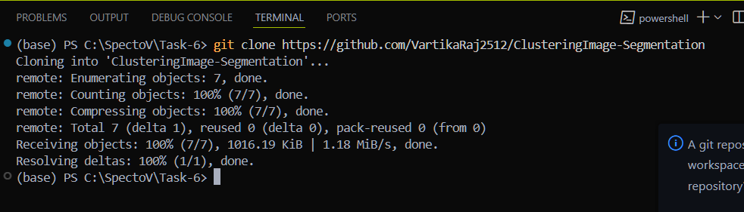  
  
Navigate to the folder

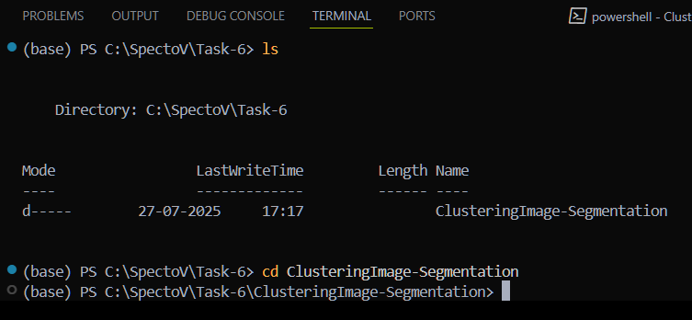

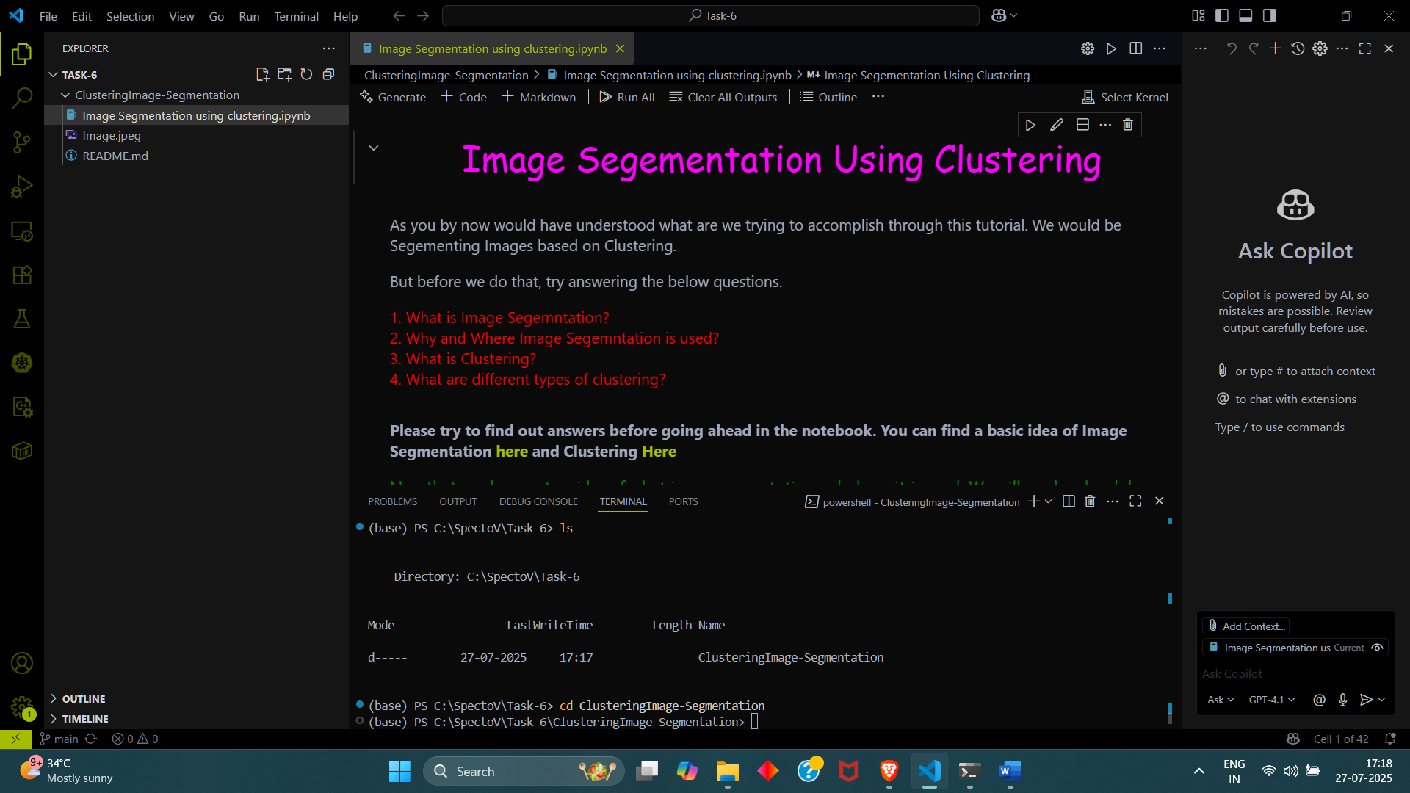

Creating conda environment/ reusing previously made environment   
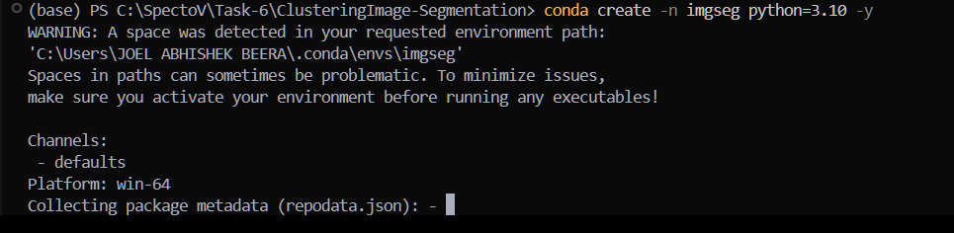

Activate environment  
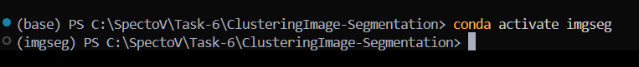  
  
Install all dependencies  
  
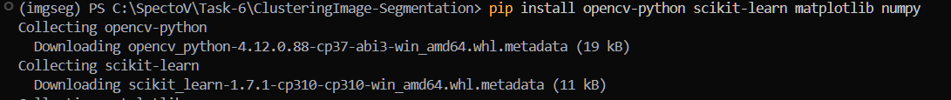

And run the ipynb file  
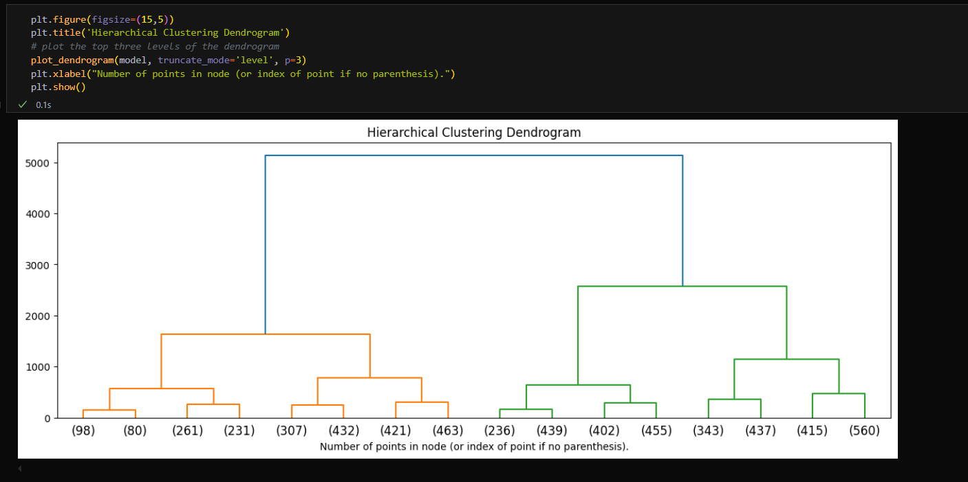  
the green tick indicates it has run the cell successfully  
  
now Lets tweak a few parameters and see the results

lets try truncate_mode = lastp and p = 5

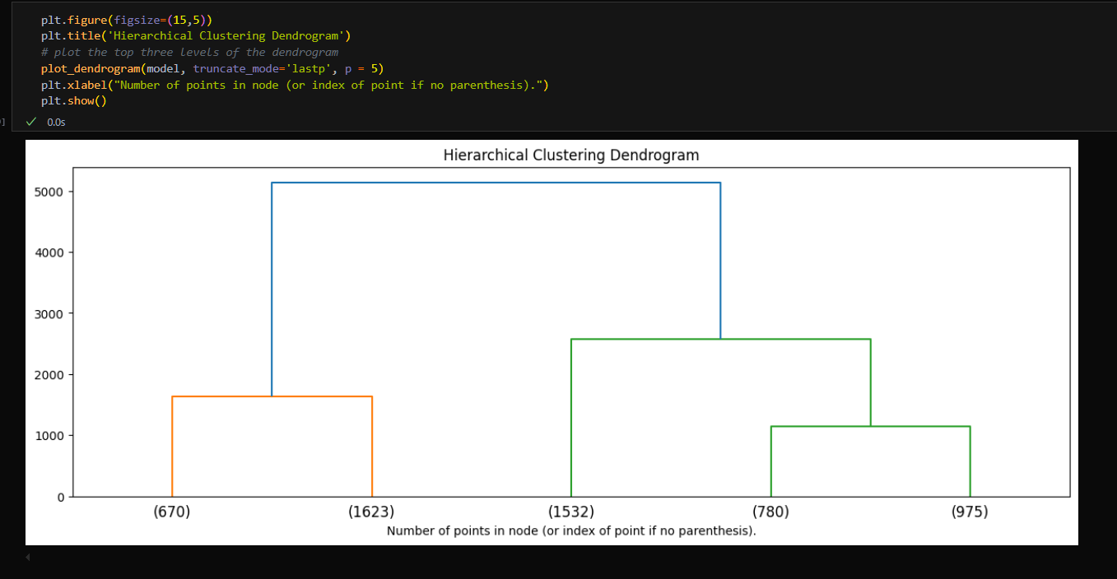

Now with p = 10  
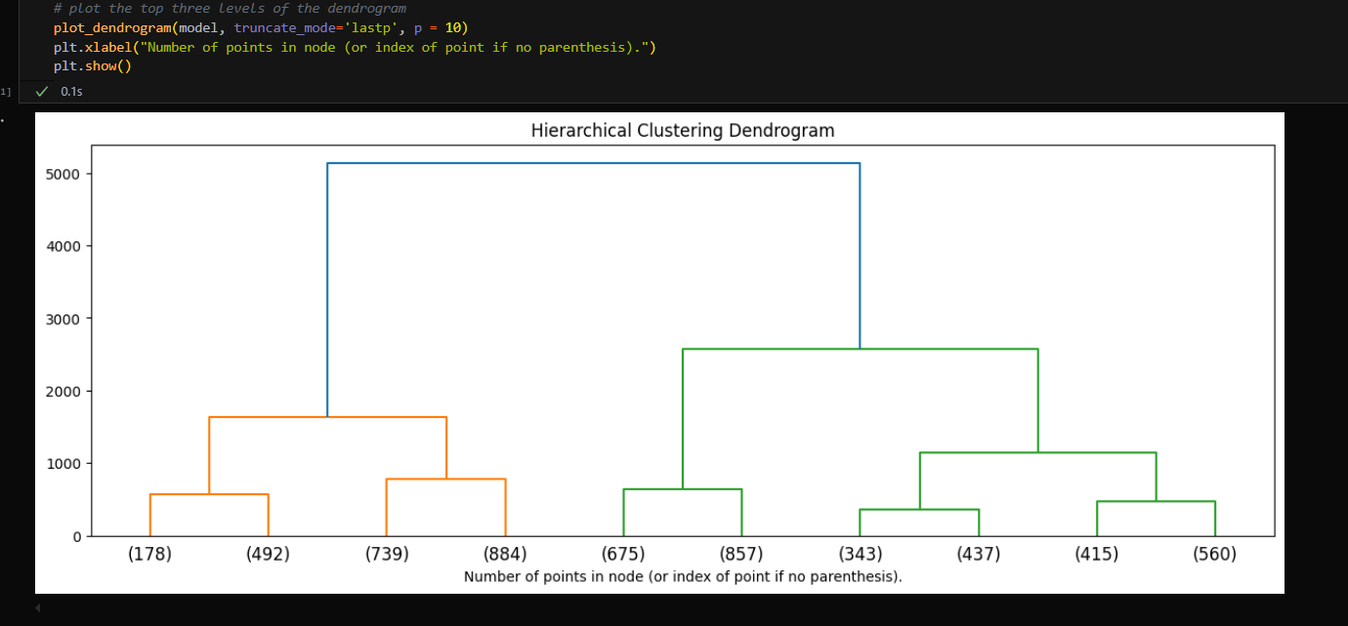

At p = 10 and level  
